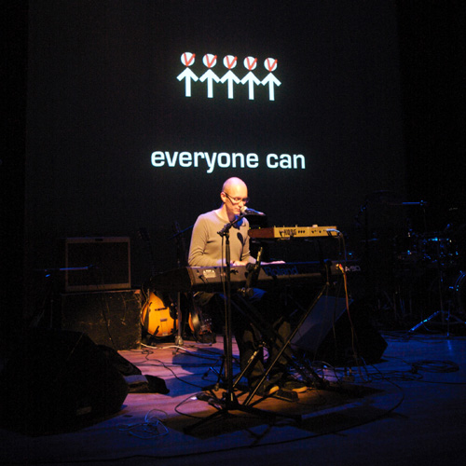

Alan Lauris
Biography

Electrosingersongwriterpop! That the unique style of the Dutch composer/producer/artist Alan Lauris. Catching, melodic, sometimes touching, often funny popsongs with jazzy, electronic and classic influences.

Alan is a classical trained pianist and wrote his first song in 1987. In the 1990’s he wrote the score for several musicals ans was half of the comedyduo ‘Alias the same’. They made 3 albums.

After a few EP’s, in 2006 Alan Lauris' first solo-album: 'Connect Me' was released on his own ‘Canan Island’ label. Many songs on this album are written together with the English lyricist John Coughlan. Alan and John won seceral songwritingprices together. In the first months of 2009 the second album ‘Different Frequency’ will be released.

Alan is also composer and/or producer for other artists.

While primary a recording-artist, he also plays live-gigs. Sometimes alone behind a grandpiano, somtimes with an electronic setup with videoprojections and animations, many of them made by Maaike Nijholt.

www.alanlauris.com
www.myspcace.com/alanlauris
www.youtube.com/alanlauris



